Names: Tri Vien Le and Alexander Lap

Problem 1: Class Diagrams for Museums in the United States
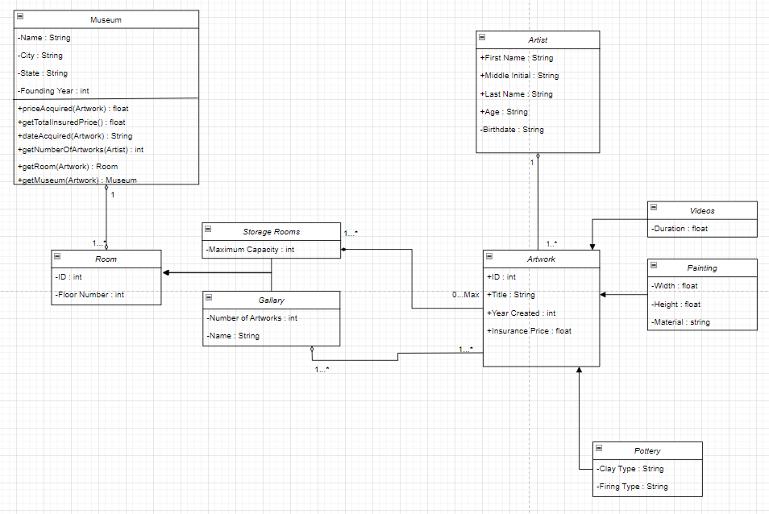

Problem 2: State Diagram for FitByte Watch
